JOB APPLICATION TRACKING SYSTEM

s

1 INTRODUCTION

1.1 OVERVIEW

An **Applicant Tracking System** or ATS is an all-in-one human resource software that automates the hiring process, helps HR teams efficiently ...

1.2 PURPOSE

An ATS creates opportunities to automate manual processes, increase visibility into the hiring cycle for the entire recruiting team, and increase opportunities for communication throughout the candidate journey. 78% of recruiters using an ATS report that it has improved the quality of the candidates they hire.

2 PROBLEM DEFINITION & DESIGN THINKING

2.1 EMPATHY MAP

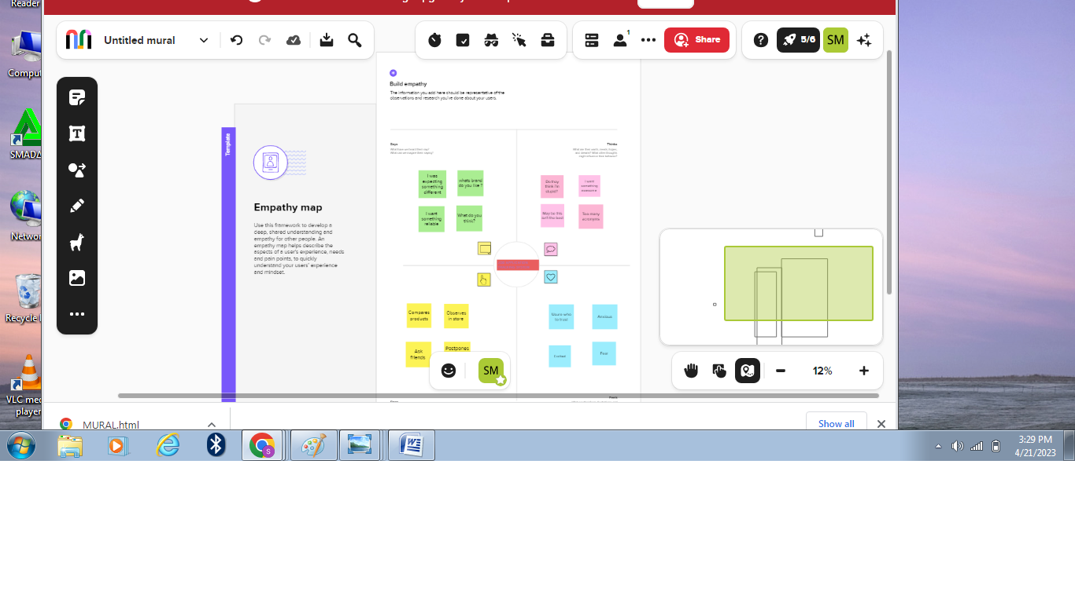

2.2 ideation &brainstorming map

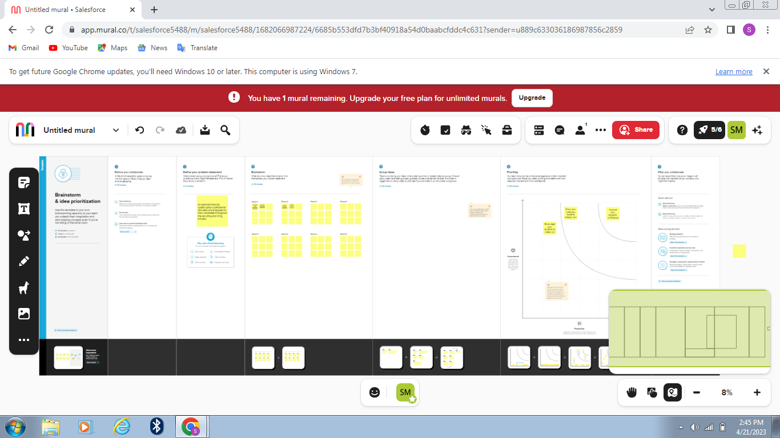

3 RESULT

3.1 DATA MODEL:

|  |  |
| --- | --- |
| Object Name | Fields in the object |
| Obj 1 | |  |  | | --- | --- | | Field label | Data type | |  |  | |  |  | |
| Obj 2 | |  |  | | --- | --- | | Field label | Data type | |  |  | |  |  | |

3.2 ACTIVITY &SCREENSHOT

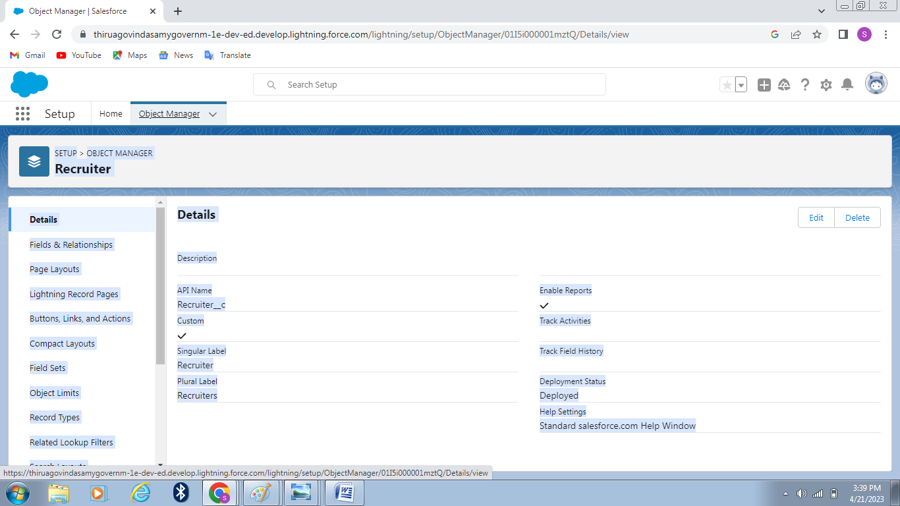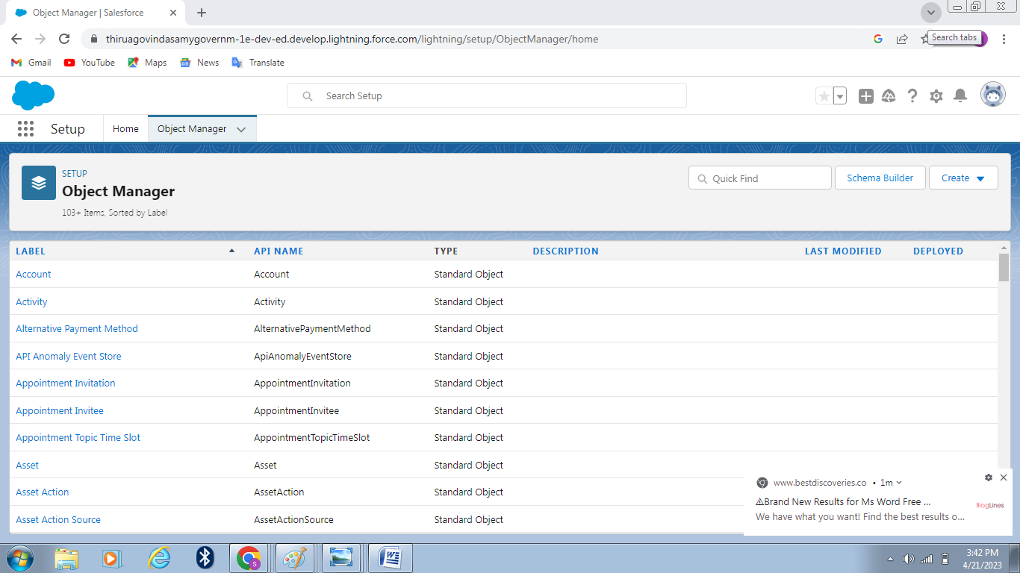

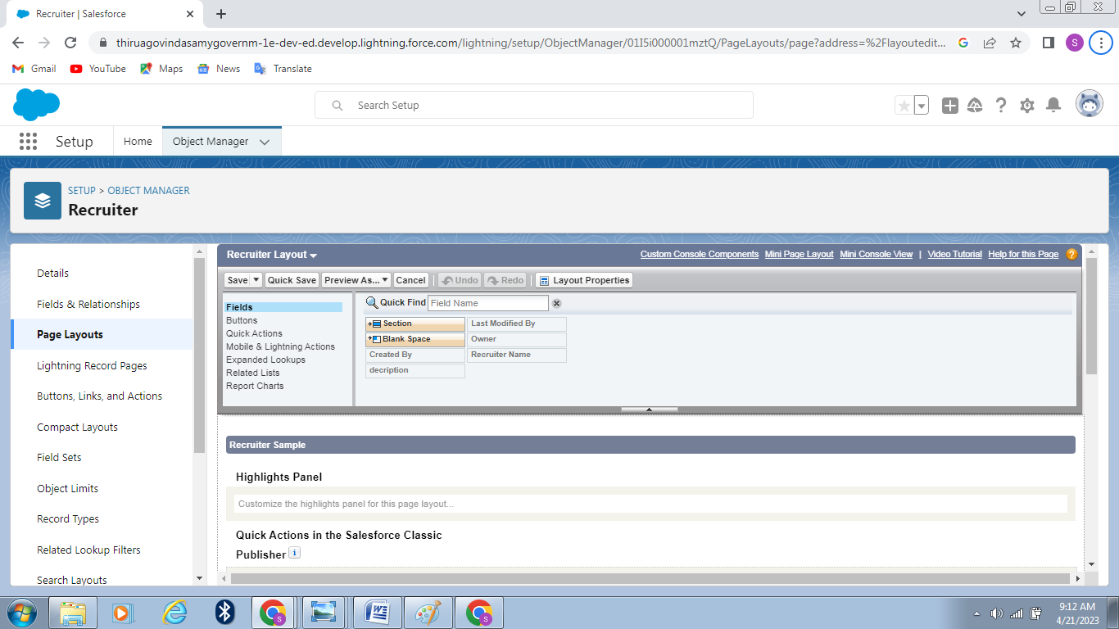

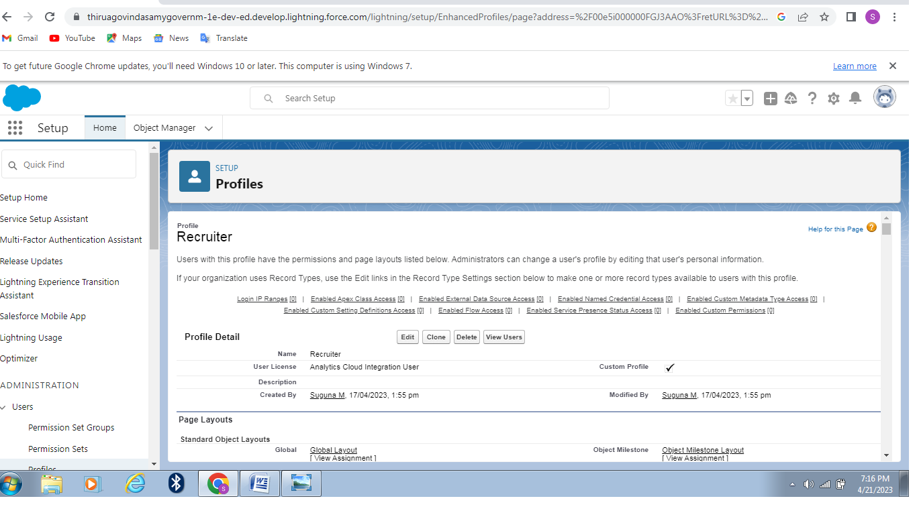

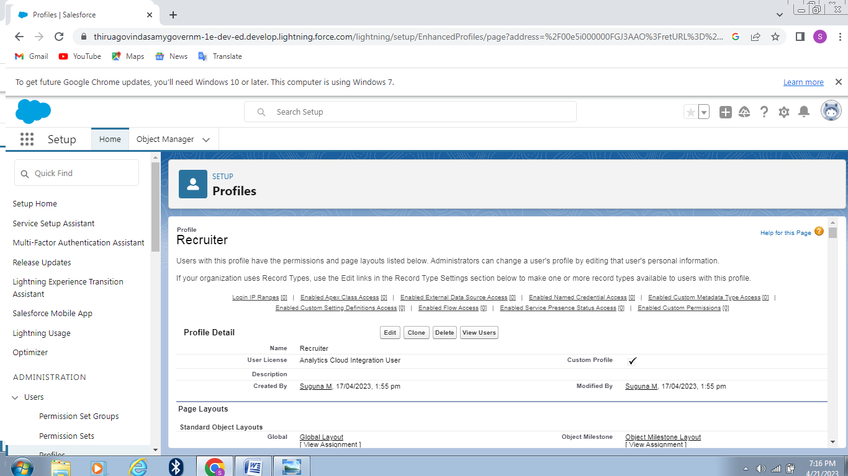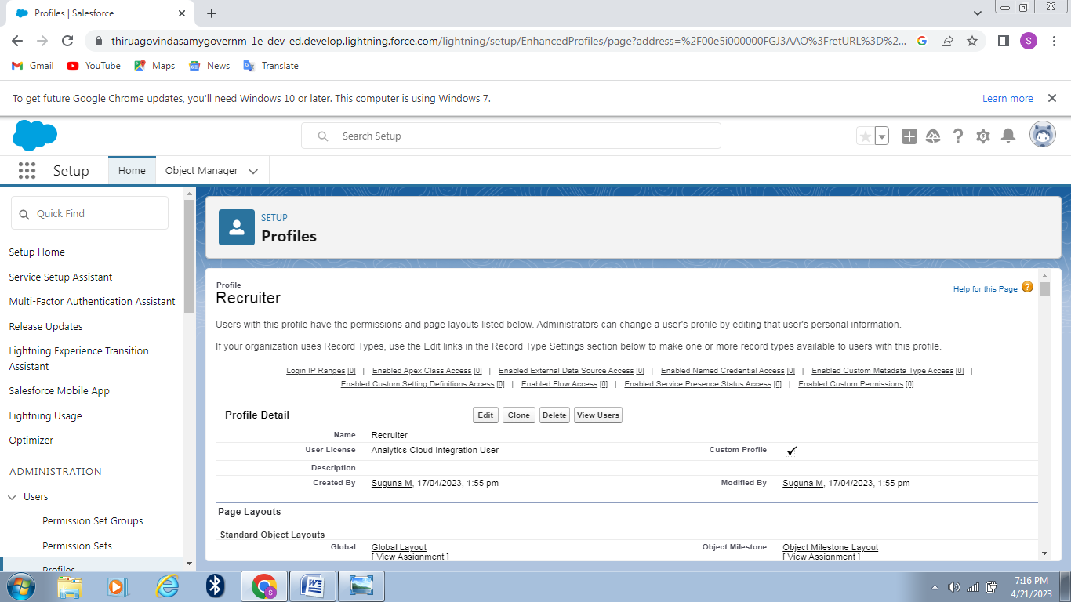

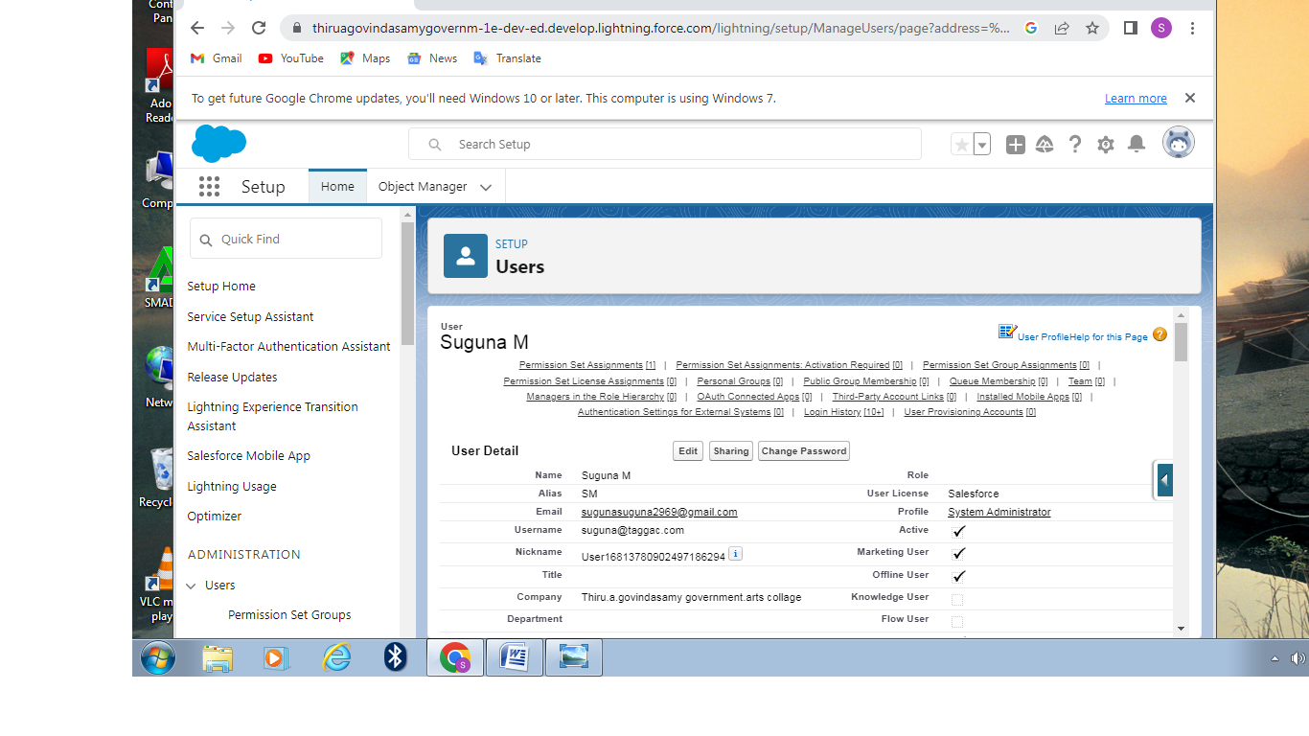



4 trailhead public BUL

Team lead-https://trailblazer.me/id/ssuguna14

Team member1-https://trailblazer.me/id/rajatb39

5 ADVANTAGES & DISADVANTAGE

Using applicant tracking software seems like a great way of saving time when recruiting. However, there could be some drawbacks, like perhaps missing out on good applicants. What are some pros and cons of using this sort of solution for recruitment?

Hiring and tracking applicants is more complex than ever before with hiring managers and recruiters stretched thin to evaluate mass amounts of candidates and find the proverbial needle in a haystack. For a quick, expedited process to find the “perfect candidate”, recruiters and hiring managers have turned to [Recruiting Software](https://www.peerspot.com/categories/applicant-tracking-and-recruiting-software), including Applicant Tracking Systems (ATS), to improve almost every aspect of the recruiting process.

Applicant Tracking Systems can relieve the various pain points in the recruiting process to ensure you’re utilizing personnel effectively and evaluating the highest quality candidates. These advantages will give you the ability to drive your business objectives forward while improving operational efficiencies.

That being said, Recruiting Software is not without its disadvantages. There are a couple situations you’ll have to look out for, but can be minimized considerably when setting up your software.

We’ve isolated the main benefits of applicant tracking systems that will help you to develop your competitive advantage, whether you’re a small business or a booming enterprise.

1. **Reduces time spent on admin tasks.** ATS software allows you to automate various tasks of the hiring process that can save you a lot of time and free up your recruiting personnel for other high-value tasks. Posting to multiple job boards, tracking candidate applications, notifying candidates individually, and scheduling interview feedback can all be automated. Not only will it speed up the time it takes to do all of those tasks, it will increase the overall quality through standardization.
2. **Resume and CV screening.** With recruiters receiving 100s of resumes per role, even scanning can take a lot of time. ATS software can be utilized to review applications and filter out candidates that don’t meet the minimum requirements of the role. So, the number of resumes a recruiter needs to review can be reduced drastically using pre-screening questions or word searches within resumes. Once again, a recruiter’s time can be redirected to higher value items of the business.
3. **Speeds up the recruitment cycle.** Having candidates’ information centralized on a single platform gives recruiters access to organized information allowing them to review and compare candidates more easily and quickly, which leads to a lower cost-per-hire. All communications, including notes, interviewer ratings, cases, and more can be stored and viewed in one location, which simplifies and speeds up the evaluation process.
4. **Improves the quality of hire.** Not only do ATS’s create more efficient workflows, as previously discussed, they can also improve the quality of your hire. First, you were able to cast a wider net by posting on job boards with standardized messaging to attract more candidates. Second, you used automated matching and filtering weed out unqualified candidates. Both benefits saved you or your recruiter the time necessary to deeply evaluate candidates and gather more insightful information so they can communicate with stakeholders and make a well-informed decision. In the end, the entire process was strengthened.
5. **Enhances reporting and compliance.** Lack of compliance in the recruiting process can devastate your business and brand. Recruiting software can help keep you stay compliant by standardizing the hiring procedures and communications. In the end, you’ll still need to create compliant standards initially, then everyone using the software will adhere to those guidelines. With all relevant in one place, reporting on recruiting performance or adherence to compliance standards becomes very simple. Automated dashboards provide management with a good view of recruiting performance.
6. **Boosts your brand.** Having a streamlined recruiting workflow and messaging can enhance the candidate experience can make a great first impression as you’re trying to attract top-notch talent.
7. **Improves onboarding.** As an extension of the recruiting process, onboarding can be streamlined as well. Once you find the right candidate, you want to onboard them as quickly as possible so they can focus on improving your business. Things like tax forms, new hire packets, IT setup requests, and more can be centralized to create a great onboarding experience for your new hire.

## Disadvantages of Applicant Tracking Systems

* **Could filter out good candidates.** When “programming” your recruiting software to recognize common keywords around roles and responsibilities, you could end up filtering out good candidates that have atypical experience or lack keywords that are aligned with what you are looking for. Careful consideration of your filters and a quality assurance process will help to fine tune the filter and reduce filtering out good candidates. This can happen with manual reviews as well, so automation, in most situations, has a net benefit.
* **Communications can be less personalized.** When automating responses to candidates, your messaging will be less personalized and can come off as robotic. Taking additional time to construct good communication can help make it feel more personalized. It’s much better to send a less personalized communication than no communication at all.

6 APPLICATIONS

The hiring process can be a time-consuming and frustrating experience for employers as well as job seekers.

To streamline the process, many companies have started using applicant tracking systems (ATS).

An ATS is a computer software program that manages the hiring process. It does this by collecting and sorting thousands of resumes.

Hiring managers can then screen candidates using the ATS, as well as track their progress through the hiring process. By digitizing the hiring process in this way, an ATS saves employers time and money.

7 CONCLUSION

Conclusion. Applicant Tracking System for recruiters is a very effective hiring solution that most of the successful recruiters utilize. Because without it, there is a good chance that your process of moving applicants through different stages can become very difficult.

8 FUTURE SCOP

Once you’ve determined your ‘why’ and ‘how’ for choosing an applicant tracking system, you’ll begin research into various systems and their features. It’s important to keep in mind that many ATS will share some similar features and functionalities, so you’ll want to look at an applicant tracking system that does more than just store candidate information.

Let’s look at the eight features your applicant tracking system should have.